**Tasks and their corresponding outputs:**

1. **Setup your machine with Git Configuration**

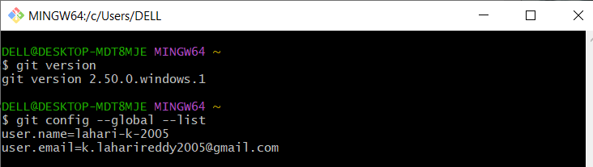

1. **Integrate notepad++.exe to Git and make it a default editor**

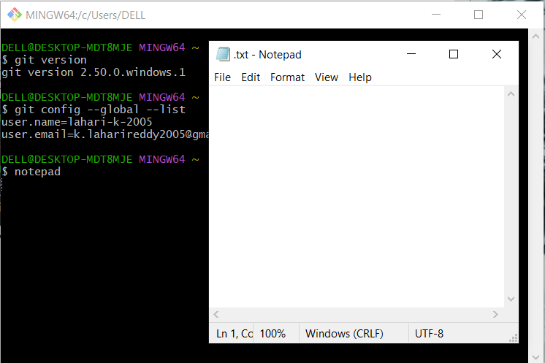



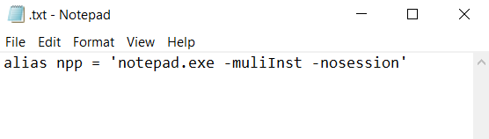

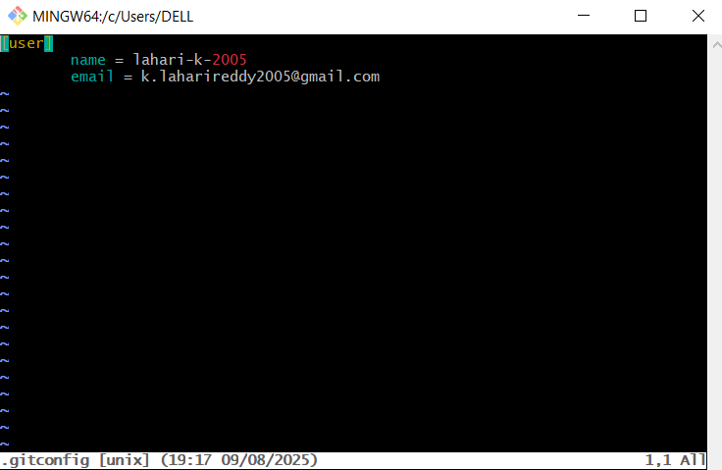

1. **Add a file to source code repository**

